High Level Design (HLD)

FLIGHT FARE PREDICTION

Revision Number – 1.0

Last Date of Revision – 14/12/2022

**Anwesha Das**

Table of Contents

Abstract 3

1 Introduction 4

1.1 Why this High-Level Design Document? 4

1.2 Description 4

1.3 Problem Statement 4

1.4. Project Solution 5

1.5 Answer enhancements 5

1.6 Technical needs 5

1.7 Information needs 5

1.8Tools Used 6

1.9 Constraints 6

1.10 Assumptions 6

2.1 and 2.2 Design flow 7

2.3 Logging 7

2.4 Error Handling 7

3 Performance analysis 8

3.1 Reusability 8

3.2 Application Compatibility 8

3.3 Resource Utilization 8

Conclusion 8

# Abstract

Travelling through flights has become an integral part of today’s lifestyle as more and more people are opting for faster travelling options. The flight ticket prices increase or decrease every now and then depending on various factors like timing of the flights, destination, and duration of flights various occasions such as vacations or festive Season. Therefore, having some basic idea of the flight fares before planning the trip will surely help many people save money and time. The main goal is to predict the fares of the flights based on different factors available in the provided dataset.

# 1 Introduction

# 1.1 Why this High-Level Design Document?

The main purpose of this HLD documentation is to feature the required details of the project and supply the outline of the machine learning model and also the written code. This additionally provides the careful description on however the complete project has been designed end-to-end.

# 1.2 Description

**Problem Perspective**

The flight fare prediction may be a machine learning model that helps people to predict the price of the flight price tag and helps the users to understand the price of their journey.

# 1.3 Problem Statement

The most goal of the project is to form a programme that predicts the price of the flight price tag by taking bound input from the user like date of journey, location and destination etc.

# 1.4. Project Solution

Project requires the desired input of user from the created interface and method all the provided information to satisfy the wants of the machine learning model and at last show the expected output.

# 1.5 Answer enhancements

We will even predict the price of price tag considering whether or not is it a weekday, season or alternative social reasons. However, considering from the

Angle of business, if we have a tendency to method such information and predict the price of the discounted price tag it'll bring some loss to the airlines company. Therefore, this technique isn't thought-about.

# 1.6 Technical needs

There are not any hardware needs needed for victimization this application, the user should have an interactive device that has access to the web and should have the fundamental understanding of providing the input. And for the backend half the server should run all the package that's needed for the process and provided information to show the results.

# 1.7 Information needs

The info demand is totally supported the matter statement. And also, the information set is accessible on the ineuron within the type of standout sheet (.xlsx), because the main theme of the project is to induce the expertise of real time issues, we have a tendency to once more mercantilism the information into the prophetess data base and commerce it into csv format.

# 1.8Tools Used

* Python 3.8 is employed because the programming language and frame works like numpy, pandas, and sklearn and alternative modules for building the model.
* Vscode is employed as IDE.
* For visualizations seaborn and components of matplotlib are getting used.
* For information assortment prophetess info is getting used.
* Front end development is completed victimization HTML/CSS.
* Flask is employed for each information and backend readying.
* GitHub is employed for version management.

# 1.9 Constraints

The flight fare prediction answer should be user friendly, as automatic as attainable and also the user should not be needed to understand any of the operating.

# 1.10 Assumptions

The most objective of the project is to implement the utilization cases as for the new dataset that user provides through the programme. Machine learning model is employed for process the on top of computer file. It's additionally assumed that each one aspects of this project have the flexibility to figure along within the approach as the designer is expecting.

# 2.1 and 2.2 Design flow

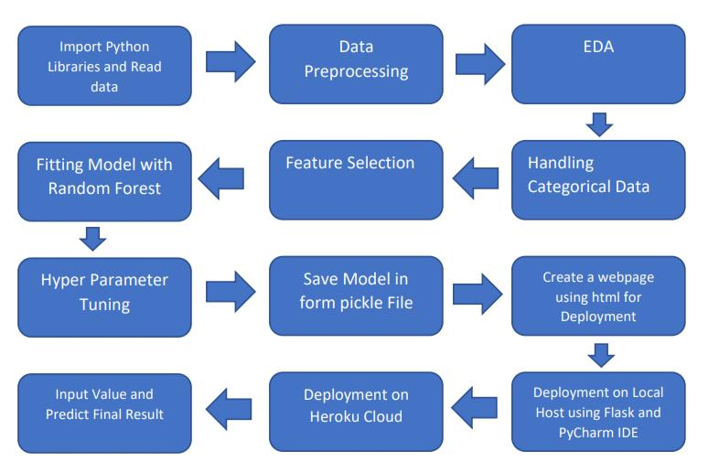

# 2.3 Logging

Each step is being logged within the system that runs internally, that shows the date time and therefore the processed that has been performed, work is completed in several layers as information, DEBUG, ERROR, and WARNINGS. This provides us the perceive of the logged info.

# 2.4 Error Handling

Once ever a slip is occurred, the reason are logged in its several log file, in order that the developer will rectify the error.

# 3 Performance analysis

# 3.1 Reusability

Elements of the code written is accustomed different applications and therefore the rest is changed and be reused.

# 3.2 Application Compatibility

The various parts for this project are exploitation python as associate interface between them. Every element can have its own tasks to perform, and it's the work of the python to make sure correct transfer of data.

# 3.3 Resource Utilization

Once any task is performed, it'll doubtless; use all the process power offered till that performs is finished.

# Conclusion

The flight fare prediction will predict the worth supported the trained knowledge set within the rule. Therefore, the user will recognize the approximate value for his or her journey.